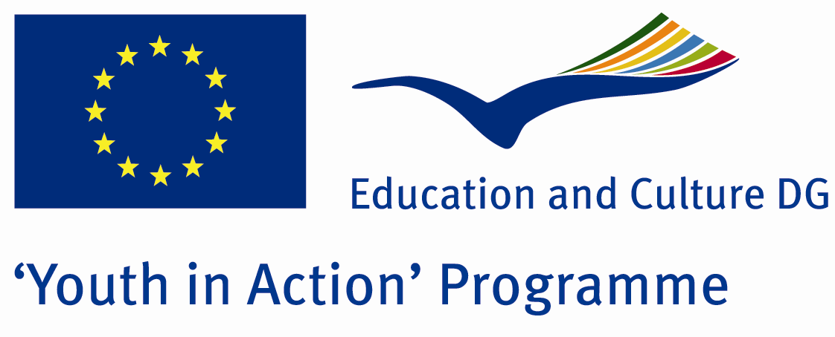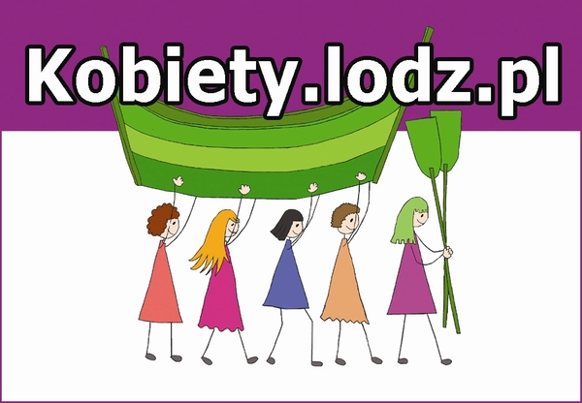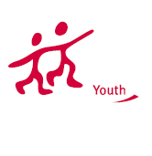

“Women of Europe”

Action 1.1. – Youth Exchange
Lodz, Poland 23/09/2012 – 30/09/2012

We are very glad to invite you to the Youth exchange with the title “Women of Europe” which will be organized by kobiety.lodz.pl in Lodz, Poland between 23rd and 30th September 2012.
Theme: The theme of this youth exchange is the way we perceive the image and role of women in the society in different parts of Europe. Through the topics related to women issues participants will address and discuss current European challenges and problems. We are going to discover the cultural similarities and differences in participants’ countries. The main objectives of the project are to raise awareness of participants’ own and identity and culture and to cross borders to other traditions, languages and mentalities by involving actively with groups from other countries. One important part will be the addressing of prejudice in the stereotypical image of women and what are the ways to overcome this.
We will ask participants to bring photos presenting the image of women in their countries and the way they are perceived. Participants will find out more about the topics related to women in their countries through the photography, discussions, group work, quizzes, games and workshops. Working in multicultural groups they will also broaden their horizons and improve mutual understanding within Europe and learn how to benefit from our diversity. By sharing the experiences and ideas participants will get closer to the other cultures and will develop the understanding of stereotypes and gender inequality.
Social photography workshops will be a part of this Youth Exchange program. Participants will learn how to address social issues on the photographs. At the end of the YE participants will present the results of the learning process and sharing experiences during the photo exhibition. All participants should bring their own photo camera.
Also during the project we will organize intercultural nights where all the partner groups will present their country, their culture, traditional foods, drinks, music and dances.
Duration: 8 days (including travel)
23 September 2012 – arrival day
30 September 2012– departure day

Place: Łódź, Poland
Target Group: young people between 18-30 (men and women)
Number of participants: 5 participants + 1 leader from each country

Project's language: English

Number of participants: 48

Application deadline: 17th April 2012
Costs covered by the Organizers: 70% of travel expenses, 100% food and accommodation.
Contact person: Katarzyna Stępień

Mail: katarzyna.kobiety@gmail.com
I enclose the Part III, if you are interested in joining this project, please fill it in, stamp and sign and send me a scan of this document back by email or by fax (katarzyna.kobiety@gmail.com and fax: 0048 42 6327977 with information “for Kobiety”.)
We will need the original Part III as well so please send it to:
Youth in Action
kobiety.lodz.pl
al. Kościuszki 48
90-427 Łódź
POLAND
We would like to apply for the project with the deadline of 1st of May 2012 to the Polish National Agency.
If you have any questions, please do not hesitate to contact me.

Thank you and best regards,
Katarzyna Stępień

Project coordinator
kobiety.lodz.pl
al. Kościuszki 48
90-427 Łódź
Poland
mobile: +48 503 008 095
e-mail: katarzyna.kobiety@gmail.com

